PRACTICAL - 2

Implement functions to print nth Fibonacci number using iteration and recursive method. Compare the performance of two methods by counting number of steps executed on various inputs. Also draw a comparative chart. (Fibonacci series 1, 1, 2, 3, 5, 8….. Here 8 is the 6th Fibonacci number)

CODE:

#include <stdio.h>

int count_ite=0;

int count_rec=0;

void fib_ite(int );

int fib_rec(int n );

int main(){ int n;

printf("enter the fib no = "); scanf("%d",&n);

fib_ite(n); int ans=fib_rec(n);

printf("%dth number is = %d\n",n,ans);

printf("recursion step count = %d\n",count_rec); return

0;

}

void fib_ite(int n ){

int n1=0; int

n2=1; int n3,i;

if(n==0) {

count_ite++;

n3=0;

} else {

for(i=2;i<=n;i++){ count_ite++; n3=n1+n2; count_ite++; n1=n2; count_ite++;

n2=n3;

}

}

printf("iteration step count = %d\n",count_ite);

printf("%dth number is = %d\n",n,n3);

}

int fib_rec(int n){ if(n==0){

count_rec++;

return 0;

}

else if(n==1){ count_rec++;

return 1;

}

else{

count_rec++;

return fib_rec(n-1)+fib_rec(n-2);

}

}

OUTPUT:

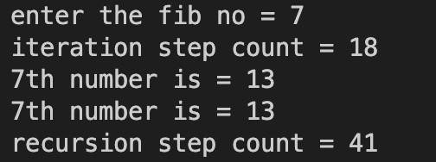

GRAPH:

